UNITED STATES
SECURITIES AND EXCHANGE COMMISSION
WASHINGTON, D.C. 20549

SCHEDULE 14A
(Rule 14a-101)

SCHEDULE 14A INFORMATION
PROXY STATEMENT PURSUANT TO SECTION 14(A) OF THE
SECURITIES EXCHANGE ACT OF 1934

Filed by the Registrant ☒ Filed by a Party other than the Registrant o

Check the appropriate box:

☐ | Preliminary Proxy Statement
o | Confidential, for Use of the Commission Only (as permitted by Rule 14a-6(e)(2))
o | Definitive Proxy Statement
x | Definitive Additional Materials
o | Soliciting Material Pursuant to § 240.14a-12

INSEEGO CORP.
(Name of Registrant as Specified in Its Charter)

Payment of Filing Fee (Check the appropriate box)

x | No fee required.
o | Fee computed on table below per Exchange Act Rules 14a-6(i)(1) and 0-11
 | (1) | Title of each class of securities to which transaction applies:
 | (2) | Aggregate number of securities to which transaction applies:
 | (3) | Per unit price or other underlying value of transaction computed pursuant to Exchange Act Rule 0-11 (set forth the amount on which the filing fee is calculated and state how it was determined):
 | (4) | Proposed maximum aggregate value of transaction:
 | (5) | Total fee paid:
o | Fee paid previously with preliminary materials:
o | Check box if any part of the fee is offset as provided by Exchange Act Rule 0-11(a)(2) and identify the filing for which the offsetting fee was paid previously. Identify the previous filing by registration statement number, or the Form or Schedule and the date of its filing.
 | (1) | Amount previously paid:
 | (2) | Form, Schedule or Registration Statement No.:
 | (3) | Filing Party:
 | (4) | Date Filed:

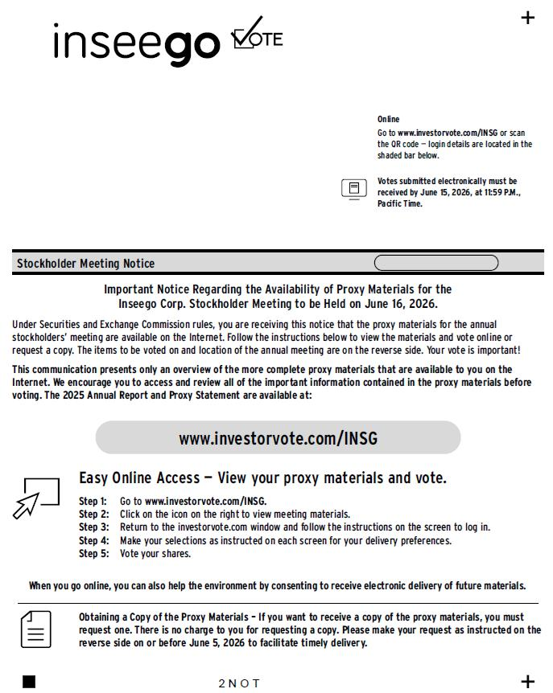

www.investorvote.com/INSG Easy Online Access — View your proxy materials and vote. Step 1: Step 2: Step 3: Step 4: Step 5: Go to www.investorvote.com/INSG. Click on the icon on the right to view meeting materials. Return to the investorvote.com window and follow the instructions on the screen to log in. Make your selections as instructed on each screen for your delivery preferences. Vote your shares. Online Go to www.investorvote.com/INSG or scan the QR code — login details are located in the shaded bar below. Stockholder Meeting Notice 1234 5678 9012 345 Important Notice Regarding the Availability of Proxy Materials for the Inseego Corp. Stockholder Meeting to be Held on June 16, 2026. Under Securities and Exchange Commission rules, you are receiving this notice that the proxy materials for the annual stockholders’ meeting are available on the Internet. Follow the instructions below to view the materials and vote online or request a copy. The items to be voted on and location of the annual meeting are on the reverse side. Your vote is important! This communication presents only an overview of the more complete proxy materials that are available to you on the Internet. We encourage you to access and review all of the important information contained in the proxy materials before voting. The 2025 Annual Report and Proxy Statement are available at: 04A1NB When you go online, you can also help the environment by consenting to receive electronic delivery of future materials. Obtaining a Copy of the Proxy Materials – If you want to receive a copy of the proxy materials, you must request one. There is no charge to you for requesting a copy. Please make your request as instructed on the reverse side on or before June 5, 2026 to facilitate timely delivery. 2 N O T Votes submitted electronically must be received by June 15, 2026, at 11:59 P.M., Pacific Time. MMMMMMMMMMMM MMMMMMMMM 000001 MR A SAMPLE DESIGNATION (IF ANY) ADD 1 ADD 2 ADD 3 ADD 4 ADD 5 ADD 6 ENDORSEMENT_LINE SACKPACK C 1234567890 C O Y MMMMMMM

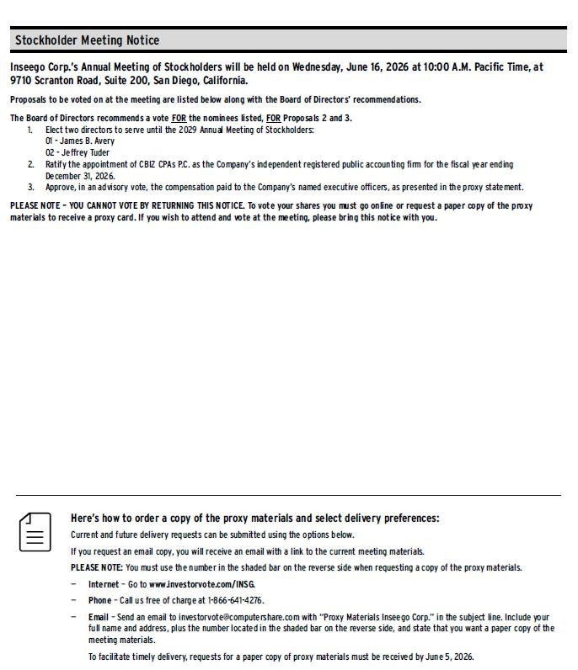

Here’s how to order a copy of the proxy materials and select delivery preferences: Current and future delivery requests can be submitted using the options below. If you request an email copy, you will receive an email with a link to the current meeting materials. PLEASE NOTE: You must use the number in the shaded bar on the reverse side when requesting a copy of the proxy materials. — Internet – Go to www.investorvote.com/INSG. — Phone – Call us free of charge at 1 - 866 - 641 - 4276. — Email – Send an email to investorvote@computershare.com with “Proxy Materials Inseego Corp.” in the subject line. Include your full name and address, plus the number located in the shaded bar on the reverse side, and state that you want a paper copy of the meeting materials. To facilitate timely delivery, requests for a paper copy of proxy materials must be received by June 5, 2026. Stockholder Meeting Notice Inseego Corp.’s Annual Meeting of Stockholders will be held on Wednesday, June 16, 2026 at 10:00 A.M. Pacific Time, at 9710 Scranton Road, Suite 200, San Diego, California. Proposals to be voted on at the meeting are listed below along with the Board of Directors’ recommendations. The Board of Directors recommends a vote FOR the nominees listed, FOR Proposals 2 and 3. 1. Elect two directors to serve until the 2029 Annual Meeting of Stockholders: 01 - James B. Avery 02 - Jeffrey Tuder 2. Ratify the appointment of CBIZ CPAs P.C. as the Company’s independent registered public accounting firm for the fiscal year ending December 31, 2026. 3. Approve, in an advisory vote, the compensation paid to the Company’s named executive officers, as presented in the proxy statement. PLEASE NOTE – YOU CANNOT VOTE BY RETURNING THIS NOTICE. To vote your shares you must go online or request a paper copy of the proxy materials to receive a proxy card. If you wish to attend and vote at the meeting, please bring this notice with you.

