UNITED STATES
SECURITIES AND EXCHANGE COMMISSION
Washington, D.C. 20549

FORM 8-K

CURRENT REPORT
Pursuant to Section 13 or 15(d) of the
Securities Exchange Act of 1934

Date of Report (Date of earliest event reported): May 7, 2026

INSEEGO CORP.
(Exact Name of Registrant as Specified in Charter)

Delaware |  | 001-38358 |  | 81-3377646
(State or other jurisdiction  of incorporation) |  | (Commission File Number) |  | (IRS Employer  Identification No.)

9710 Scranton Road, Suite 200
San Diego, California 92121
(Address of principal executive offices) (Zip Code)

(858) 812-3400
(Registrant’s telephone number, including area code)

Not Applicable
(Former name or former address, if changed since last report)

Check the appropriate box below if the Form 8-K filing is intended to simultaneously satisfy the filing obligation of the registrant under any of the following provisions:

☐ | Written communications pursuant to Rule 425 under the Securities Act (17 CFR 230.425)

☐ | Soliciting material pursuant to Rule 14a-12 under the Exchange Act (17 CFR 240.14a-12)

☐ | Pre-commencement communications pursuant to Rule 14d-2(b) under the Exchange Act (17 CFR 240.14d-2(b))

☐ | Pre-commencement communications pursuant to Rule 13e-4(c) under the Exchange Act (17 CFR 240.13e-4(c))

Title of each class | Trading Symbol(s) | Name of each exchange on which registered
Common Stock, par value $0.001 per share | INSG | Nasdaq Global Select Market

Indicate by check mark whether the registrant is an emerging growth company as defined in Rule 405 of the Securities Act of 1933 (§230.405 of this chapter) or Rule 12b-2 of the Securities Exchange Act of 1934 (§240.12b-2 of this chapter).

Emerging growth company ☐

If an emerging growth company, indicate by check mark if the registrant has elected not to use the extended transition period for complying with any new or revised financial accounting standards provided pursuant to Section 13(a) of the Exchange Act. ☐

Item 2.02. | Results of Operations and Financial Condition.

On May 7, 2026, Inseego Corp. (the “Company”) issued a press release containing preliminary financial results for the quarter ended March 31, 2026. On May 7, 2026, the Company also posted an investor presentation to its website at https://investor.inseego.com/events-presentations (the “Company Earnings Presentation”). The text of the press release and Company Earnings Presentation are furnished as Exhibits 99.1 and 99.2 to this Form 8-K and incorporated herein by reference.

The information in “Item 2.02 Results of Operations and Financial Condition” of this Current Report on Form 8-K and in Exhibit 99.1, attached hereto, is furnished and shall not be deemed “filed” for purposes of Section 18 of the Securities Exchange Act of 1934, as amended (the “Exchange Act”), or otherwise subject to the liabilities of that section. It may be incorporated by reference in a filing under the Exchange Act or the Securities Act of 1933, as amended, only if such subsequent filing specifically references such disclosure in this Form 8-K.

Item 9.01. | Financial Statements and Exhibits.

(d) Exhibits.

The following Exhibits are filed with this report:

Exhibit No. | Description
99.1 | Press Release dated May 7, 2026, containing Inseego Corp. preliminary financial results for the quarter ended March 31, 2026
99.2 | Company Earnings Presentation, dated May 7, 2026
104 | Cover Page Interactive Data File (embedded within the Inline XBRL document).

2

SIGNATURE

Pursuant to the requirements of the Securities Exchange Act of 1934, the registrant has duly caused this Current Report on Form 8-K to be signed on its behalf by the undersigned hereunto duly authorized.

 | INSEEGO CORP.
 | By: | /s/ Steven Gatoff
 |  | Steven Gatoff
 |  | Chief Financial Officer
Date: May 7, 2026

3

Exhibit 99.1


Inseego Reports First Quarter 2026 Financial Results

Q1 2026 revenue of $34.3 million

Q1 2026 Adjusted EBITDA* of $1.8 million and GAAP Net Loss of $4.5 million

Announced acquisition of Nokia’s Fixed Wireless Access business, expected to close Q4 2026

SAN DIEGO—May 7, 2026—Inseego Corp. (Nasdaq: INSG) (the “Company”), a leader in cloud-first wireless edge solutions, today reported its results for the first quarter of 2026 ended March 31, 2026.

“We delivered results within guidance in Q1 and continued to execute on our strategy to further diversify our customers and product portfolio,” said Juho Sarvikas, CEO of Inseego. “As we have communicated previously, we are focused on investment in the first half of 2026, in particular for carrier ramps, product launches, and portfolio expansion. We continued to execute against this strategy in Q1, which will drive revenue and profitability expansion in the second half of the year. While our focus continues to be on organic growth and execution, I am very excited about our acquisition of Nokia’s FWA business, which will be a transformational acquisition for us, provides immediate global scale, and accelerates our strategy in a very significant way.”

Steven Gatoff, CFO of Inseego, added: “We delivered year-over-year revenue growth in Q1, along with healthy gross margins and Adjusted EBITDA within our guided range. We continue to invest in the product, go-to-market, and operating capabilities needed to support the large opportunity ahead. We are working towards closing the FWA acquisition with Nokia and look forward to welcoming them as a significant shareholder and partner.”

Q1 2026 Financial Highlights

 | • | Total revenue for Q1 2026 was $34.3 million.
 | • | Adjusted EBITDA* for Q1 2026 was $1.8 million. GAAP Net Loss was $4.5 million.
 | • | GAAP gross margin for Q1 2026 was 48.3%, the Company’s fifth consecutive quarter with gross margin exceeding 40%.

Business Highlights

 | • | Announced signing of agreement to acquire Nokia’s Fixed Wireless Access business, which is expected to close in Q4 2026 subject to normal terms and conditions of transactions like this. Based on its current run rate of approximately $200m in annualized revenue, the acquisition is expected to double Inseego’s revenue upon closing.
 | • | Under the terms of the FWA acquisition, at closing Nokia will receive approximately a 7% equity stake in Inseego in the form of common stock and warrants, representing a value of $20 million. At closing Nokia will also make an additional $10 million cash investment in Inseego in the form of common stock and warrants, to further strengthen the commercial collaboration, that will bring Nokia’s total ownership interest to approximately 11%.
 | • | The acquisition of the Nokia FWA business also includes plans for joint go-to-market initiatives between the two companies in 6G and wireless edge to capture the opportunities in AI and to further advance the FWA business. The collaboration will also explore joint innovation and carrier 5G monetization opportunities, as well as consumer and enterprise growth opportunities at the wireless edge. These efforts are expected to support and drive customer continuity, future revenue growth, and technology leadership at the wireless edge.
 | • | Secured a new win with a U.S. Tier-1 carrier partner for our 4th generation FWA device, as carriers continue to view Inseego as a key partner in scaling Fixed Wireless Access as a core enterprise connectivity solution.
 | • | Continued to consolidate the Mobile hot spot space by securing a new win with a U.S. Tier-1 carrier partner for a value-tier MiFi device.
 | • | Announced the appointment of Koroush Saraf as Chief Product Officer, as we continue to expand our product portfolio and drive the delivery of more integrated and scalable solutions for enterprise and service provider customers.

1

Investor Events

Inseego management will be participating in the following upcoming investor events:

 | • | May 27, 2026 – TD Cowen 54th Annual Technology, Media & Telecom Conference (New York, NY)

Q2 and Full-Year 2026 Guidance

 | – | Q2 2026 total revenue in the range of $36.5 million to $43.5 million.
 | – | Q2 2026 Adjusted EBITDA* in the range of $250 thousand to $2.0 million.
 | – | Full-year 2026 total revenue of approximately $190 million

Conference Call Information

Inseego will host a conference call and live webcast today at 5:00 p.m. ET. A Q&A session will be held live directly after the prepared remarks. To access the conference call:

 | • | Online, visit https://investor.inseego.com/events-presentations
 | • | Those without internet access or unable to pre-register may dial in by calling:
 | • | In the United States, call 1-844-282-4463
 | • | International parties can access the call at 1-412-317-5613

An audio replay of the conference call will be available one hour after the call through May 21, 2026. To hear the replay, parties in the United States may call 1-855-669-9658 and enter access code 2654418 followed by the # key. International parties may call 1-412-317-0088. In addition, the Inseego Corp. press release will be accessible from the Company's website before the conference call begins.

*Adjusted EBITDA is a non-GAAP financial measure. See “Non-GAAP Financial Measures” below for more information, and the tables at the end of this release for a reconciliation to the closest GAAP measure.

About Inseego Corp.

Inseego is a leader in cloud-first wireless edge solutions, delivering secure, resilient connectivity across people, places, and machines. As wireless becomes foundational infrastructure, Inseego unifies connectivity, management, security, and subscriber lifecycle management into a platform that orchestrates cellular, satellite, Wi-Fi, and emerging wireless technologies at the edge.

Its portfolio includes 5G fixed wireless access routers, MiFi mobile hotspots IoT solutions under the Skyus brand, and cloud platforms including Inseego Connect and Inseego Subscribe, all designed in the U.S. Built on its core strength and long-term leadership in cellular technology, Inseego solutions enable service providers and channel partners to deploy and manage enterprise-grade wireless solutions at scale. Learn more at www.inseego.com.

© 2026. Inseego Corp. All rights reserved. The Inseego name and logo are trademarks of Inseego Corp.

2

Cautionary Note Regarding Forward-Looking Statements
Some of the information presented in this news release may constitute forward-looking statements within the meaning of the Private Securities Litigation Reform Act of 1995. In this context, forward-looking statements often address expected future business and financial performance and often contain words such as “may,” “estimate,” “anticipate,” “believe,” “expect,” “intend,” “plan,” “project,” “will” and similar words and phrases indicating future results. The information presented in this news release related to our financial guidance, future business outlook, the future demand for our products, and other statements that are not purely historical facts are forward-looking. These forward-looking statements are based on management’s current expectations, assumptions, estimates, and projections. They are subject to significant risks and uncertainties that could cause results to differ materially from those anticipated in such forward-looking statements. We, therefore, cannot guarantee future results, performance, or achievements. Actual results could differ materially from our expectations.

Factors that could cause actual results to differ materially from the Company’s expectations include: (1) the Company’s dependence on a small number of customers for a substantial portion of our revenues; (2) the future demand for wireless broadband access to data and device management software and services and our ability to accurately forecast; (3) the growth of wireless wide-area networking and device management software and services; (4) customer and end-user acceptance of the Company’s current product and service offerings and market demand for the Company’s anticipated new product and service offerings; (5) our ability to develop sales channels and to onboard channel partners; (6) increased competition and pricing pressure from participants in the markets in which the Company is engaged; (7) dependence on third-party manufacturers and key component suppliers worldwide; (8) the impact of fluctuations of foreign currency exchange rates; (9) the impact of supply chain challenges on our ability to source components and manufacture our products; (10) unexpected liabilities or expenses; (11) the Company’s ability to introduce new products and services in a timely manner, including the ability to develop and launch 5G products at the speed and functionality required by our customers; (12) litigation, regulatory and IP developments related to our products or components of our products; (13) the Company’s ability to raise additional financing when the Company requires capital for operations or to satisfy corporate obligations; (14) the Company’s plans and expectations relating to acquisitions, divestitures, strategic relationships, international expansion, software and hardware developments, personnel matters, and cost containment initiatives, including restructuring activities and the timing of their implementations; (15) the global semiconductor shortage and any related price increases or supply chain disruptions, (16) the potential impact of COVID-19 or other global public health emergencies on the business, (17) the impact of high rates of inflation and rising interest rates, (18) the impact of import tariffs on our materials and products, and (19) the impact of geopolitical instability on our business.

Additionally, in connection with Inseego’s planned acquisition (“Proposed Transaction”) of Nokia’s Fixed Wireless Access business (the “Business”), factors that may cause actual results to differ materially from current expectations include, but are not limited to: (1) the occurrence of any event, change or other circumstances that could give rise to the termination of the Asset Purchase Agreement with respect to the Proposed Transaction, (2) the outcome of any legal proceedings that may be instituted against the parties following the announcement of the Proposed Transaction; (3) the inability to complete the Proposed Transaction, including due to failure to satisfy any conditions to closing; (4) the risk that the announcement and/or consummation of the Proposed Transaction disrupts Inseego’s current plans or operations; (5) the ability to recognize the anticipated benefits of the Proposed Transaction, which may be affected by, among other things, the potential loss of customers and/or employees of the Business, competition, and/or the ability of Inseego to grow and manage growth profitably; (6) the risk that Inseego will not be able to integrate the Business successfully; (7) the risk that costs savings and other anticipated synergies from the Proposed Transaction may not be realized when expected, or at all; (8) the diversion of Inseego’s management’s time on issues related to the Proposed Transaction.

These factors, as well as other factors set forth as risk factors or otherwise described in the reports filed by the Company with the SEC (available at www.sec.gov), could cause results to differ materially from those expressed in the Company’s forward-looking statements. The Company assumes no obligation to update publicly any forward-looking statements, even if new information becomes available or other events occur in the future, except as otherwise required under applicable law and our ongoing reporting obligations under the Securities Exchange Act of 1934, as amended.

3

Non-GAAP Financial Measures

Inseego Corp. has provided financial information in this press release that has not been prepared in accordance with GAAP. Non-GAAP net income (loss) and non-GAAP net income (loss) per share, for example, exclude the impact of share-based compensation expense, impairment of capitalized software, amortization of intangible assets purchased through acquisitions, non-recurring transaction related costs, and other non-recurring gains and losses. Adjusted EBITDA, in addition to those items excluded from non-GAAP net income (loss), excludes all interest expense, taxes, depreciation, amortization, and other non-operating income/expense.
Non-GAAP net income (loss), non-GAAP net income (loss) per share, and Adjusted EBITDA are supplemental measures of our performance that are not required by, or presented in accordance with, GAAP. These non-GAAP financial measures have limitations as an analytical tool. They are not intended to be used in isolation or as a substitute for cost of revenues, operating expenses, net income (loss), net income (loss) per share or any other performance measure determined in accordance with GAAP. We present these non-GAAP financial measures because we consider them to be an important supplemental performance measure.

We use these non-GAAP financial measures to make operational decisions, evaluate our performance, prepare forecasts and determine compensation. Further, management and investors benefit from referring to these non-GAAP financial measures in assessing our performance when planning, forecasting and analyzing future periods. Share-based compensation expenses are expected to vary depending on the number of new incentive award grants issued to both current and new employees, the number of such grants forfeited by former employees, and changes in our stock price, stock market volatility, expected option term and risk-free interest rates, all of which are difficult to estimate. In calculating non-GAAP financial measures, we exclude certain non-cash and one-time items to facilitate comparability of our operating performance on a period-to-period basis because such expenses are not, in our view, related to our ongoing operational performance. We use this view of our operating performance to compare it with the business plan and individual operating budgets and in the allocation of resources.

We believe that these non-GAAP financial measures are helpful to investors in providing greater transparency to the information used by management in its operational decision-making. The Company believes that using these non-GAAP financial measures also facilitates comparing our underlying operating performance with other companies in our industry, which use similar non-GAAP financial measures to supplement their GAAP results.

In the future, we expect to continue to incur expenses similar to the non-GAAP adjustments described above, and the exclusion of these items in the presentation of our non-GAAP financial measures should not be construed as an inference that these costs are unusual, infrequent, or non-recurring. Investors and potential investors are cautioned that material limitations are associated with using non-GAAP financial measures as an analytical tool. The limitations of relying on non-GAAP financial measures include, but are not limited to, the fact that other companies, including other companies in our industry, may calculate non-GAAP financial measures differently than we do, limiting their usefulness as a comparative tool.

Investors and potential investors are encouraged to review the reconciliation of our non-GAAP financial measures in this press release with our GAAP financial results.

Investor Relations Contact:
Matt Glover, Gateway Group: (949) 574-3860
IR@inseego.com

4

INSEEGO CORP.
CONSOLIDATED STATEMENTS OF OPERATIONS
(In thousands, except share and per share data)
(Unaudited)

Three Months Ended
March 31,
 |  | 2026 |  |  |  | 2025
Revenues:
Mobile solutions |  | $ | 16,688 |  |  | $ | 17,790
Fixed wireless access solutions |  |  | 5,314 |  |  |  | 1,903
Product |  |  | 22,002 |  |  |  | 19,693
Software services and other |  |  | 12,336 |  |  |  | 11,980
Total revenues |  |  | 34,338 |  |  |  | 31,673
Cost of revenues:
Product |  |  | 16,382 |  |  |  | 15,396
Software services and other |  |  | 1,359 |  |  |  | 1,294
Total cost of revenues |  |  | 17,741 |  |  |  | 16,690
Gross profit |  |  | 16,597 |  |  |  | 14,983
Operating costs and expenses:
Research and development |  |  | 5,810 |  |  |  | 4,535
Sales and marketing |  |  | 5,622 |  |  |  | 3,934
General and administrative |  |  | 6,937 |  |  |  | 4,490
Depreciation and amortization |  |  | 1,794 |  |  |  | 2,064
Impairment of capitalized software |  |  | – |  |  |  | 384
Total operating costs and expenses |  |  | 20,163 |  |  |  | 15,407
Operating income (loss) |  |  | (3,566 | ) |  |  | (424 | )
Other (expense) income:
Interest expense |  |  | (1,061 | ) |  |  | (1,026 | )
Other income (expense), net |  |  | 125 |  |  |  | 303
Income (loss) before income taxes |  |  | (4,502 | ) |  |  | (1,147 | )
Income tax provision (benefit) |  |  | 34 |  |  |  | 23
Income (loss) from continuing operations |  |  | (4,536 | ) |  |  | (1,170 | )
Income (loss) from discontinued operations, net of income tax provision |  |  | – |  |  |  | (400 | )
Net income (loss) |  |  | (4,536 | ) |  |  | (1,570 | )
Preferred stock dividends |  |  | – |  |  |  | (864 | )
Preferred stock exchange deemed contribution |  |  | 15,100 |  |  |  | –
Net income (loss) attributable to common stockholders |  | $ | 10,564 |  |  | $ | (2,434 | )
Per share data:
Net earnings (loss) per share
Basic
Continuing operations |  | $ | 0.66 |  |  | $ | (0.14 | )
Discontinued operations |  | $ | – |  |  | $ | (0.03 | )
Basic earnings (loss) per share* |  | $ | 0.66 |  |  | $ | (0.16 | )
Diluted
Continuing operations |  | $ | 0.65 |  |  | $ | (0.14 | )
Discontinued operations |  | $ | – |  |  | $ | (0.03 | )
Diluted earnings (loss) per share* |  | $ | 0.65 |  |  | $ | (0.16 | )
Weighted-average shares used in computation of net earnings (loss) per share
Basic |  |  | 16,093,430 |  |  |  | 15,002,003
Diluted |  |  | 16,356,246 |  |  |  | 15,002,003
* Rounding may impact summation of amounts

5

INSEEGO CORP.
CONSOLIDATED BALANCE SHEETS
(In thousands)
(Unaudited)

 |  | March 31,  2026 |  |  |  | December 31,  2025
ASSETS
Current assets:
Cash and cash equivalents |  | $ | 19,297 |  |  | $ | 24,886
Accounts receivable, net |  |  | 15,719 |  |  |  | 25,086
Inventories |  |  | 12,541 |  |  |  | 7,726
Prepaid expenses and other current assets |  |  | 5,704 |  |  |  | 6,389
Total current assets |  |  | 53,261 |  |  |  | 64,087
Property, plant and equipment, net |  |  | 1,308 |  |  |  | 1,087
Intangible assets, net |  |  | 21,873 |  |  |  | 20,676
Goodwill |  |  | 3,949 |  |  |  | 3,949
Operating lease right-of-use assets |  |  | 3,235 |  |  |  | 3,451
Other assets |  |  | 531 |  |  |  | 557
Total assets |  | $ | 84,157 |  |  | $ | 93,807
LIABILITIES AND STOCKHOLDERS’ DEFICIT
Current liabilities:
Accounts payable |  | $ | 24,741 |  |  | $ | 23,583
Accrued expenses and other current liabilities |  |  | 27,397 |  |  |  | 24,856
Total current liabilities |  |  | 52,138 |  |  |  | 48,439
Long-term liabilities:
Operating lease liabilities |  |  | 2,649 |  |  |  | 2,910
Deferred tax liabilities, net |  |  | 189 |  |  |  | 186
2029 Senior Secured Notes, net |  |  | 50,415 |  |  |  | 41,611
Other long-term liabilities |  |  | 4,181 |  |  |  | 4,705
Total liabilities |  |  | 109,572 |  |  |  | 97,851
Commitments and contingencies
Stockholders’ deficit:
Preferred stock (no shares outstanding as of March 31, 2026; aggregate liquidation preference of $41,966 as of December 31, 2025) |  |  | – |  |  |  | –
Common stock |  |  | 16 |  |  |  | 15
Additional paid-in capital |  |  | 871,990 |  |  |  | 903,899
Accumulated other comprehensive loss |  |  | 376 |  |  |  | 403
Accumulated deficit |  |  | (897,797 | ) |  |  | (908,361 | )
Total stockholders’ deficit |  |  | (25,415 | ) |  |  | (4,044 | )
Total liabilities and stockholders’ deficit |  | $ | 84,157 |  |  | $ | 93,807

6

INSEEGO CORP.
CONSOLIDATED STATEMENTS OF CASH FLOWS
(In thousands)
(Unaudited)

Three Months Ended
March 31,
 |  | 2026 |  |  |  | 2025
Cash flows from operating activities:
Net income (loss) |  | $ | (4,536 | ) |  | $ | (1,570 | )
Adjustments to reconcile net loss to net cash provided by (used in) operating activities:
(Income) Loss from discontinued operations, net of tax |  |  | – |  |  |  | 400
Depreciation and amortization |  |  | 1,813 |  |  |  | 2,098
Provision for expected credit losses |  |  | (14 | ) |  |  | 14
Impairment of capitalized software |  |  | – |  |  |  | 384
Provision for excess and obsolete inventory |  |  | 312 |  |  |  | 680
Share-based compensation expense |  |  | 2,304 |  |  |  | 1,601
Amortization of debt discount (premium) and debt issuance costs, net |  |  | (114 | ) |  |  | (22 | )
Deferred income taxes |  |  | 3 |  |  |  | 3
Non-cash operating lease expense |  |  | 216 |  |  |  | 263
Other |  |  | 79 |  |  |  | –
Changes in assets and liabilities:
Accounts receivable |  |  | 9,381 |  |  |  | 1,698
Inventories |  |  | (5,127 | ) |  |  | (2,218 | )
Prepaid expenses and other assets |  |  | 711 |  |  |  | 1,346
Accounts payable |  |  | 2,056 |  |  |  | (850 | )
Accrued expenses and other liabilities |  |  | (5,136 | ) |  |  | (6,972 | )
Operating lease liabilities |  |  | (233 | ) |  |  | (322 | )
Operating cash flows from continuing operations |  |  | 1,715 |  |  |  | (3,467 | )
Operating cash flows from discontinued operations |  |  | – |  |  |  | –
Net cash provided by (used in) operating activities |  |  | 1,715 |  |  |  | (3,467 | )
Cash flows from investing activities:
Purchases of property, plant and equipment |  |  | (131 | ) |  |  | (32 | )
Additions to capitalized software development costs and purchases of intangible assets |  |  | (3,816 | ) |  |  | (1,693 | )
Investing cash flows from continuing operations |  |  | (3,947 | ) |  |  | (1,725 | )
Investing cash flows from discontinued operations |  |  | – |  |  |  | 710
Net cash used in investing activities |  |  | (3,947 | ) |  |  | (1,015 | )
Cash flows from financing activities:
Cash payments as part of preferred stock exchange |  |  | (3,334 | ) |  |  | –
Proceeds from stock option exercises and employee stock purchase plan, net of taxes |  |  | 1 |  |  |  | 42
Financing cash flows from continuing operations |  |  | (3,333 | ) |  |  | 42
Financing cash flows from discontinued operations |  |  | – |  |  |  | –
Net cash provided by (used in) financing activities |  |  | (3,333 | ) |  |  | 42
Effect of exchange rates on cash |  |  | (24 | ) |  |  | (7 | )
Net decrease in cash and cash equivalents |  |  | (5,589 | ) |  |  | (4,447 | )
Cash and cash equivalents, beginning of period |  |  | 24,886 |  |  |  | 39,596
Cash and cash equivalents, end of period |  | $ | 19,297 |  |  | $ | 35,149

7

INSEEGO CORP.
Supplemental Reconciliations of GAAP to Non-GAAP Financial Measures
(In thousands)
(Unaudited)

 |  | Q1 2026 |  |  |  | Q4 2025 |  |  |  | Q3 2025 |  |  |  | Q2 2025 |  |  |  | Q1 2025
GAAP Income (Loss) from continuing operations |  | $ | (4,536 | ) |  | $ | 469 |  |  | $ | 1,432 |  |  | $ | 507 |  |  | $ | (1,170 | )
Share-based compensation expense |  |  | 2,304 |  |  |  | 2,335 |  |  |  | 1,850 |  |  |  | 1,654 |  |  |  | 1,601
Impairment of capitalized software |  |  | – |  |  |  | – |  |  |  | – |  |  |  | – |  |  |  | 384
Gain on early lease termination |  |  | – |  |  |  | – |  |  |  | (443 | ) |  |  | – |  |  |  | –
Purchased intangible amortization |  |  | – |  |  |  | – |  |  |  | – |  |  |  | – |  |  |  | 316
Non-recurring transaction-related costs |  |  | 1,200 |  |  |  | – |  |  |  | – |  |  |  | – |  |  |  | –
Non-GAAP net income (loss) |  |  | (1,032 | ) |  |  | 2,804 |  |  |  | 2,839 |  |  |  | 2,161 |  |  |  | 1,131
Depreciation and amortization1 |  |  | 1,813 |  |  |  | 2,368 |  |  |  | 2,189 |  |  |  | 1,792 |  |  |  | 1,782
Interest expense |  |  | 1,061 |  |  |  | 927 |  |  |  | 885 |  |  |  | 933 |  |  |  | 1,026
Other (income) expense, net |  |  | (125 | ) |  |  | (126 | ) |  |  | (126 | ) |  |  | (182 | ) |  |  | (303 | )
Income tax provision (benefit) |  |  | 34 |  |  |  | 35 |  |  |  | (36 | ) |  |  | 22 |  |  |  | 23
Adjusted EBITDA |  | $ | 1,751 |  |  | $ | 6,008 |  |  | $ | 5,751 |  |  | $ | 4,726 |  |  | $ | 3,659
1 Excluding purchased intangible amortization

 |  | Q1 2026 |  |  |  | Q4 2025 |  |  |  | Q3 2025 |  |  |  | Q2 2025 |  |  |  | Q1 2025
INCOME (LOSS) PER DILUTED SHARE:
GAAP income (loss) from continuing operations per diluted share2 |  | $ | 0.65 |  |  | $ | (0.03 | ) |  | $ | 0.03 |  |  | $ | (0.03 | ) |  | $ | (0.14 | )
Share-based compensation expense |  |  | 0.14 |  |  |  | 0.15 |  |  |  | 0.12 |  |  |  | 0.11 |  |  |  | 0.10
Impairment of capitalized software |  |  | – |  |  |  | – |  |  |  | – |  |  |  | – |  |  |  | 0.03
Gain on early lease termination |  |  | – |  |  |  | – |  |  |  | (0.03 | ) |  |  | – |  |  |  | –
Purchased intangibles amortization &NegativeThickSpace; |  |  | – |  |  |  | – |  |  |  | – |  |  |  | – |  |  |  | 0.02
Non-recurring transaction-related costs |  |  | 0.07 |  |  |  | – |  |  |  | – |  |  |  | – |  |  |  | –
Preferred stock exchange deemed contribution |  |  | (0.94 | ) |  |  | – |  |  |  | – |  |  |  | – |  |  |  | –
Non-GAAP net income (loss) per diluted share2,3 |  | $ | (0.06 | ) |  | $ | 0.12 |  |  | $ | 0.12 |  |  | $ | 0.08 |  |  | $ | 0.02
Shares used in computing GAAP income (loss) from continuing operations per diluted share |  |  | 16,356,246 |  |  |  | 15,181,439 |  |  |  | 15,522,042 |  |  |  | 15,023,832 |  |  |  | 15,002,003
Shares used in computing non-GAAP net income (loss) per diluted share |  |  | 16,093,430 |  |  |  | 15,671,835 |  |  |  | 15,522,042 |  |  |  | 15,147,769 |  |  |  | 15,328,069
2 Includes the impact of preferred stock dividends
3 The per share reconciliation of GAAP to non-GAAP may not aggregate due to both calculations utilizing a different share basis. The loss per diluted share calculation uses a lower share count as it excludes potentially dilutive shares included in the net income per diluted share calculation.

See “Non-GAAP Financial Measures” for information regarding our use of Non-GAAP financial measures.

8

Exhibit 99.2

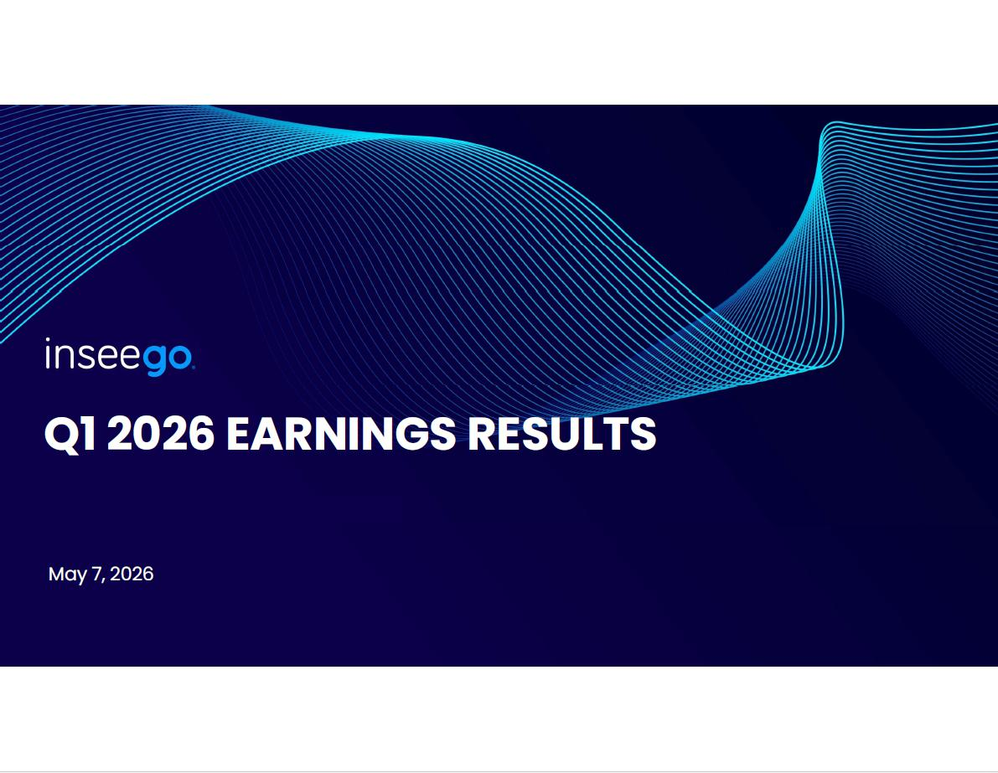

Q1 2026 EARNINGS RESULTS May 7, 2026

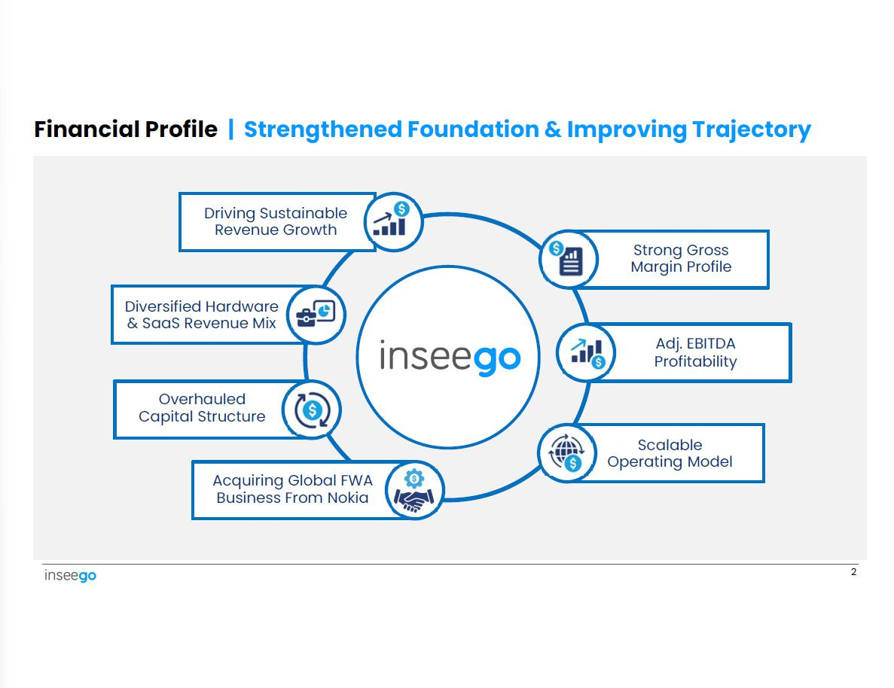

Financial Profile | Strengthened Foundation & Improving Trajectory Driving Sustainable Revenue Growth Strong Gross Margin Profile Diversified Hardware & SaaS Revenue Mix Adj. EBITDA Profitability Overhauled Capital Structure Scalable Operating Model Acquiring Global FWA Business From Nokia 2

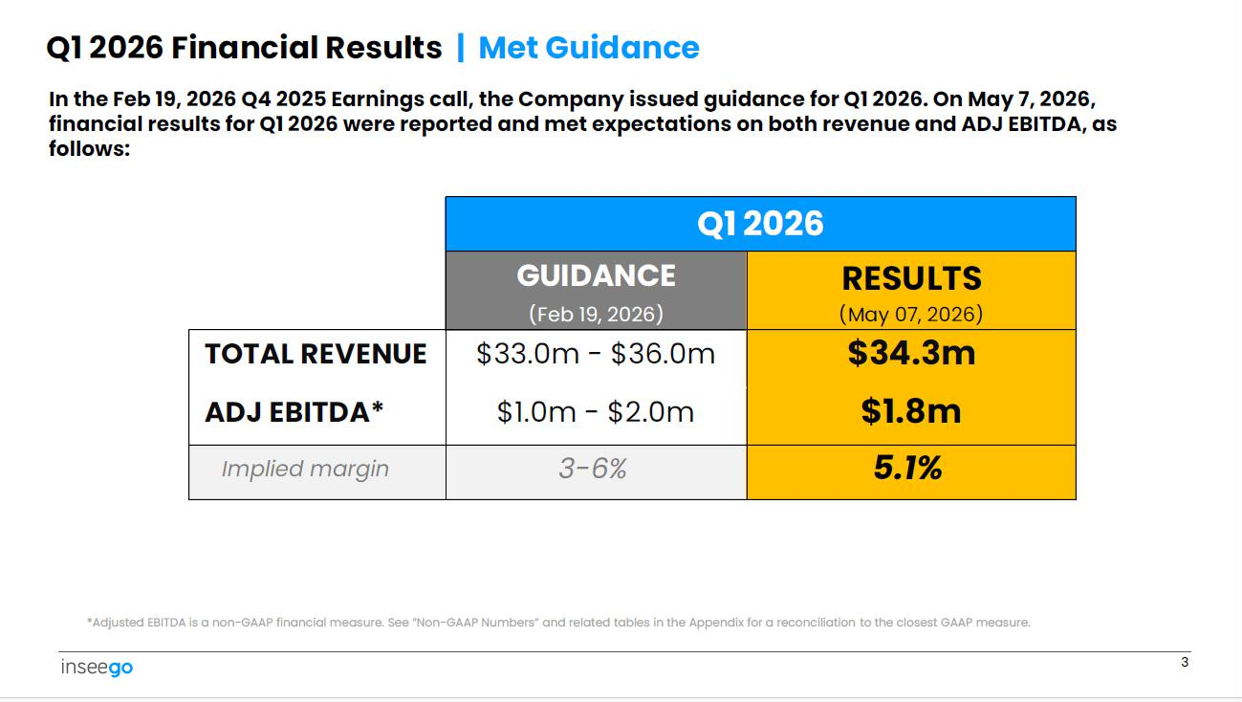

Q1 2026 RESULTS (May 07, 2026) GUIDANCE (Feb 19, 2026) $34.3m $1.8m $33.0m - $36.0m $1.0m - $2.0m TOTAL REVENUE ADJ EBITDA* 5.1% 3 - 6% Implied margin 3 Q1 2026 Financial Results | Met Guidance In the Feb 19, 2026 Q4 2025 Earnings call, the Company issued guidance for Q1 2026. On May 7, 2026, financial results for Q1 2025 were reported and met expectations on both revenue and ADJ EBITDA, as follows: *Adjusted EBITDA is a non - GAAP financial measure. See ”Non - GAAP Numbers” and related tables in the Appendix for a reconciliation to the closest GAAP measure.

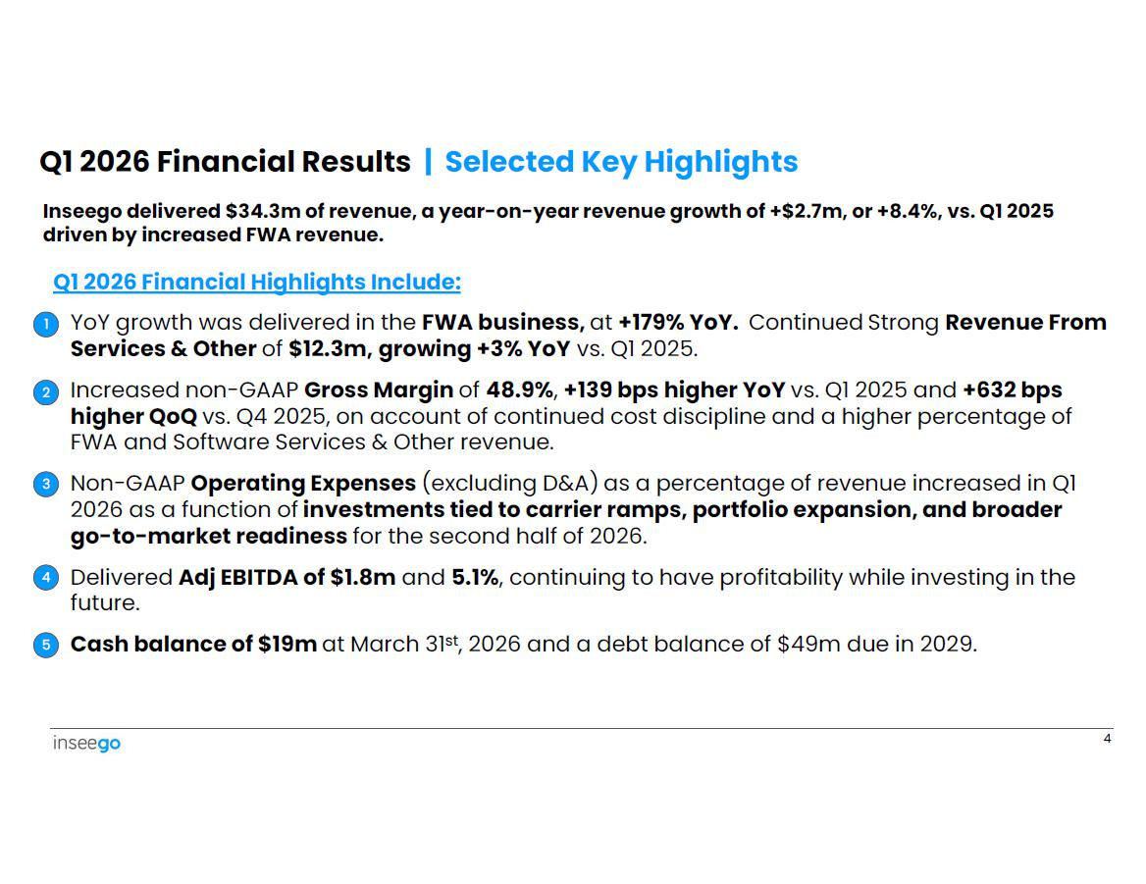

Q1 2026 Financial Results | Selected Key Highlights Inseego delivered $34.3m of revenue, a year - on - year revenue growth of +$2.7m, or +8.4%, vs. Q1 2025 driven by increased FWA revenue. Q1 2026 Financial Highlights Include: • 1 YoY growth was delivered in the FWA business, at +179% YoY. Continued Strong Revenue From Services & Other of $12.3m, growing +3% YoY vs. Q1 2025. 2 • Increased non - GAAP Gross Margin of 48.9% , +139 bps higher YoY vs. Q1 2025 and +632 bps higher QoQ vs. Q4 2025, on account of continued cost discipline and a higher percentage of FWA and Software Services & Other revenue. 3 • Non - GAAP Operating Expenses (excluding D&A) as a percentage of revenue increased in Q1 2026 as a function of investments tied to carrier ramps, portfolio expansion, and broader go - to - market readiness for the second half of 2026. 4 • Delivered Adj EBITDA of $1.8m and 5.1% , continuing to have profitability while investing in the future. 5 • Cash balance of $19m at March 31 st , 2026 and a debt balance of $49m due in 2029. 4

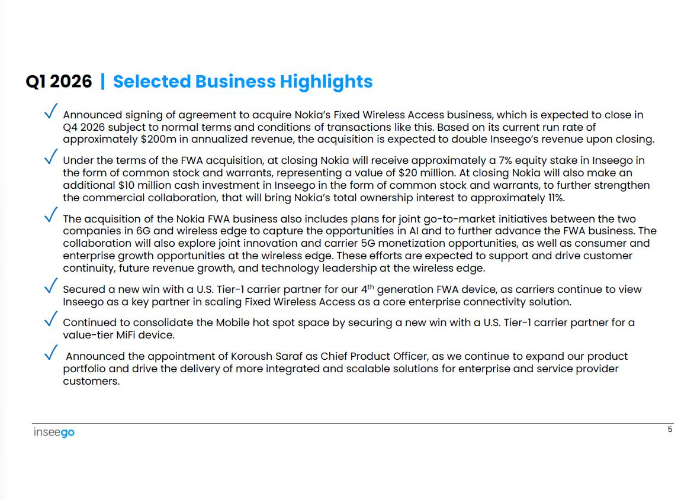

✓ Announced signing of agreement to acquire Nokia’s Fixed Wireless Access business, which is expected to close in Q4 2026 subject to normal terms and conditions of transactions like this. Based on its current run rate of approximately $200m in annualized revenue, the acquisition is expected to double Inseego’s revenue upon closing. ✓ Under the terms of the FWA acquisition, at closing Nokia will receive approximately a 7% equity stake in Inseego in the form of common stock and warrants, representing a value of $20 million. At closing Nokia will also make an additional $10 million cash investment in Inseego in the form of common stock and warrants, to further strengthen the commercial collaboration, that will bring Nokia’s total ownership interest to approximately 11%. ✓ The acquisition of the Nokia FWA business also includes plans for joint go - to - market initiatives between the two companies in 6G and wireless edge to capture the opportunities in AI and to further advance the FWA business. The collaboration will also explore joint innovation and carrier 5G monetization opportunities, as well as consumer and enterprise growth opportunities at the wireless edge. These efforts are expected to support and drive customer continuity, future revenue growth, and technology leadership at the wireless edge. ✓ Secured a new win with a U.S. Tier - 1 carrier partner for our 4 th generation FWA device, as carriers continue to view Inseego as a key partner in scaling Fixed Wireless Access as a core enterprise connectivity solution. 5 value - tier MiFi device. ✓ Continued to consolidate the Mobile hot spot space by securing a new win with a U.S. Tier - 1 carrier partner for a ✓ Announced the appointment of Koroush Saraf as Chief Product Officer, as we continue to expand our product portfolio and drive the delivery of more integrated and scalable solutions for enterprise and service provider customers. Q1 2026 | Selected Business Highlights

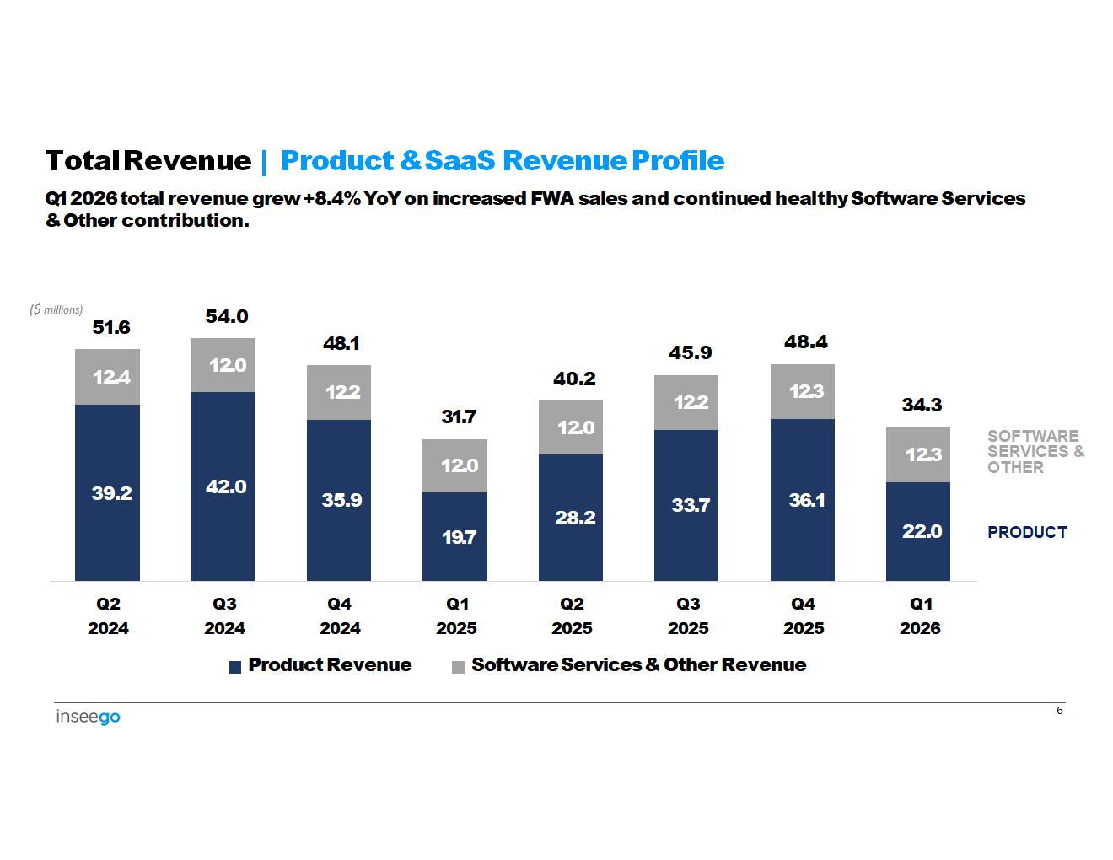
39.2 42.0 35.9 19.7 28.2 33.7 36.1 22.0 12.4 12.0 12.2 12.0 12.0 12.2 12.3 12.3 ($ millions) 51.6 54.0 48.1 31.7 40.2 45.9 48.4 34.3 Q2 2024 Q3 2024 Q4 2024 Product Revenue Q1 2025 Q2 2025 Q3 2025 Q4 2025 Q1 2026 Software Services & Other Revenue 6 Total Revenue | Product & SaaS Revenue Profile Q1 2026 total revenue grew +8.4% YoY on increased FWA sales and continued healthy Software Services & Other contribution. PRODUCT SOFTWARE SERVICES & OTHER

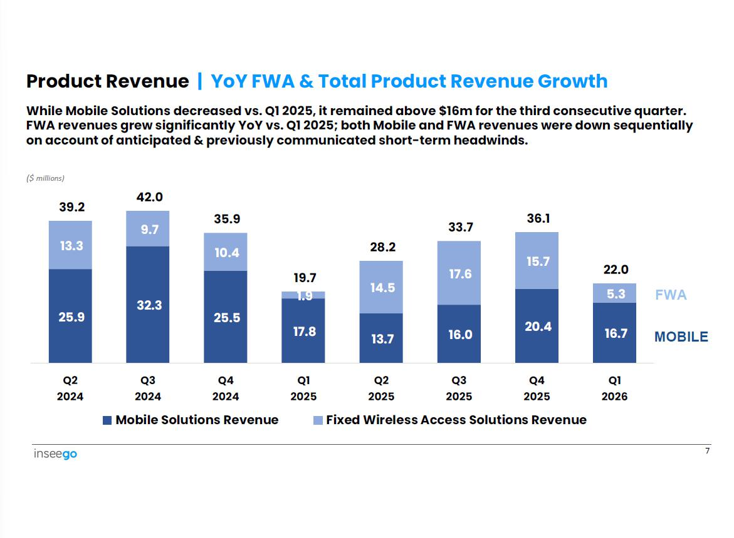

25.9 32.3 25.5 17.8 13.7 16.0 20.4 16.7 13.3 9.7 10.4 14.5 17.6 15.7 5.3 39.2 42.0 35.9 19.7 1.9 28.2 33.7 36.1 22.0 Q2 2024 Q3 2024 Q4 2024 Q1 2025 Q2 2025 Q3 2025 Q4 2025 Q1 2026 Mobile Solutions Revenue Fixed Wireless Access Solutions Revenue 7 Product Revenue | YoY FWA & Total Product Revenue Growth While Mobile Solutions decreased vs. Q1 2025, it remained above $16m for the third consecutive quarter. FWA revenues grew significantly YoY vs. Q1 2025; both Mobile and FWA revenues were down sequentially on account of anticipated & previously communicated short - term headwinds. ($ millions) MOBILE FWA

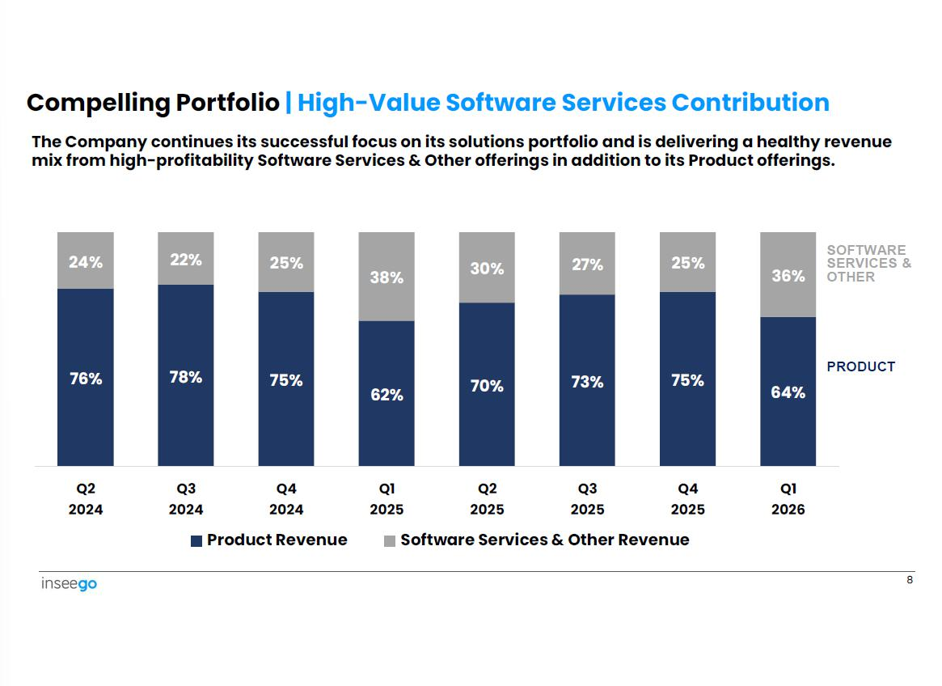

76% 78% 75% 62% 70% 73% 75% 64% 24% 22% 25% 38% 30% 27% 25% 36% Q1 Q4 Q3 Q2 Q1 Q4 Q3 Q2 2026 2025 2025 2025 2025 2024 2024 2024 Product Revenue Software Services & Other Revenue 8 Compelling Portfolio | High - Value Software Services Contribution The Company continues its successful focus on its solutions portfolio and is delivering a healthy revenue mix from high - profitability Software Services & Other offerings in addition to its Product offerings. PRODUCT SOFTWARE SERVICES & OTHER

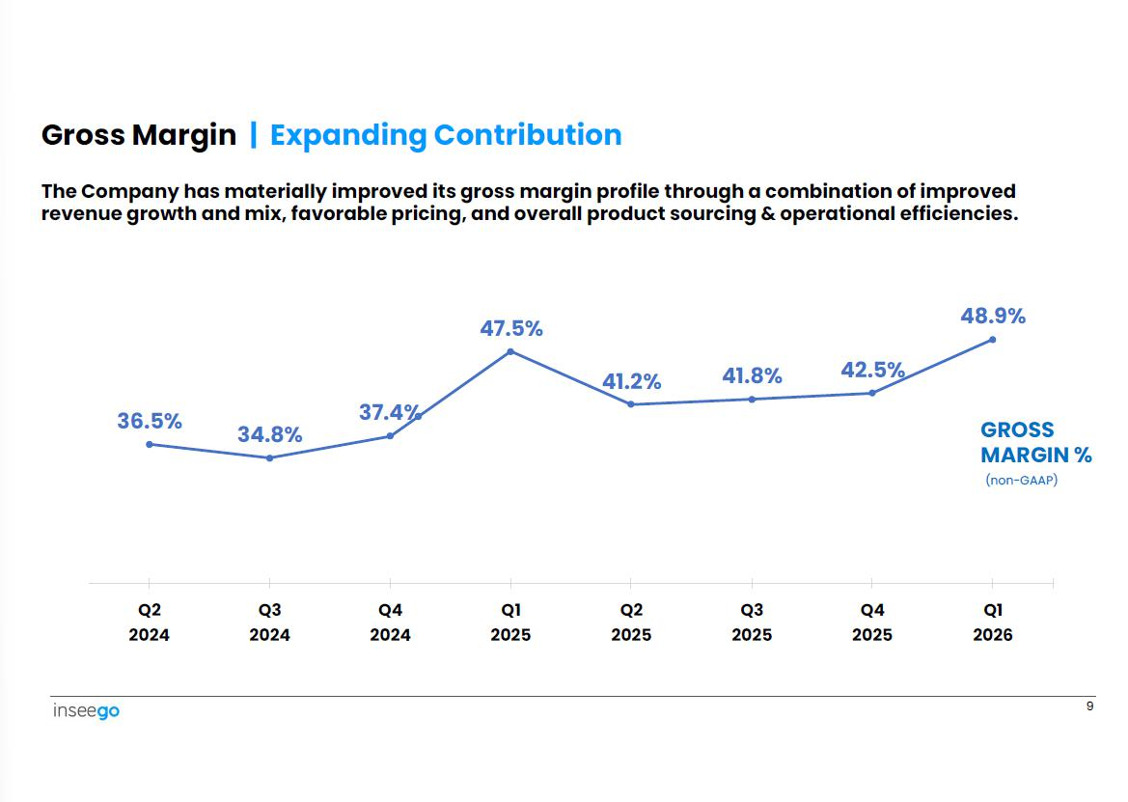

36.5% 9 34.8% 37.4% 47.5% 41.2% 41.8% 42.5% 48.9% Q1 Q4 Q3 Q2 Q1 Q4 Q3 Q2 2026 2025 2025 2025 2025 2024 2024 2024 Gross Margin | Expanding Contribution The Company has materially improved its gross margin profile through a combination of improved revenue growth and mix, favorable pricing, and overall product sourcing & operational efficiencies. GROSS MARGIN % (non - GAAP)

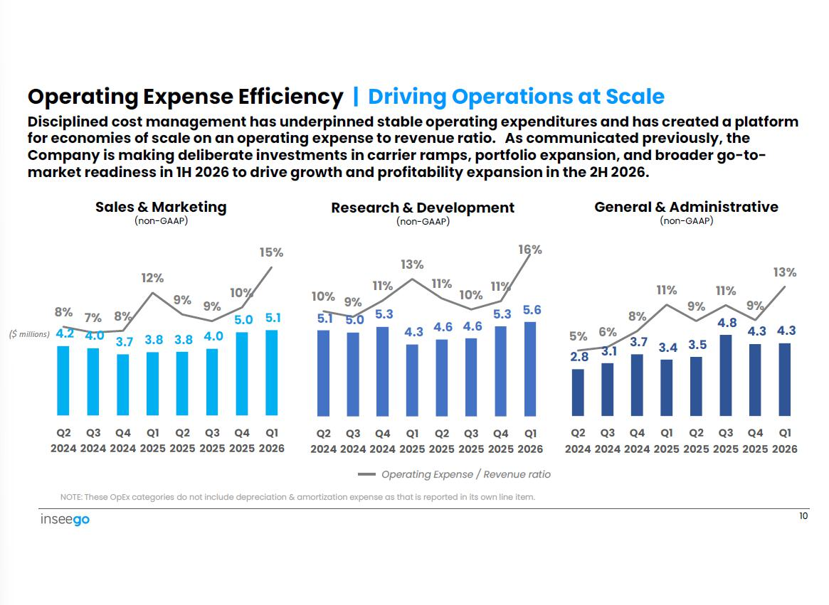

3.4 3.5 4.3 5% 2.8 6% 3.1 8% 3.7 11% 9% 11% 4.8 9% 4.3 13% 4.3 4.6 4.6 5.3 5.6 10% 5.1 9% 5.0 11% 5.3 13% 11% 10% 11% 16% Operating Expense Efficiency | Driving Operations at Scale Disciplined cost management has underpinned stable operating expenditures and has created a platform for economies of scale on an operating expense to revenue ratio. As communicated previously, the Company is making deliberate investments in carrier ramps, portfolio expansion, and broader go - to - market readiness in 1H 2026 to drive growth and profitability expansion in the 2H 2026. Sales & Marketing (non - GAAP) Research & Development (non - GAAP) General & Administrative (non - GAAP) Q2 Q3 Q4 Q1 Q2 Q3 Q4 Q1 Q2 Q3 Q4 Q1 Q2 Q3 Q4 Q1 2024 2024 2024 2025 2025 2025 2025 2026 2024 2024 2024 2025 2025 2025 2025 2026 Operating Expense / Revenue ratio NOTE: These OpEx categories do not include depreciation & amortization expense as that is reported in its own line item. 3.8 10 3.8 5.1 7% 4.0 8% 3.7 12% 9% 9% 4.0 10% 5.0 8% ($ millions) 4.2 15% Q2 Q3 Q4 Q1 Q2 Q3 Q4 Q1 2024 2024 2024 2025 2025 2025 2025 2026

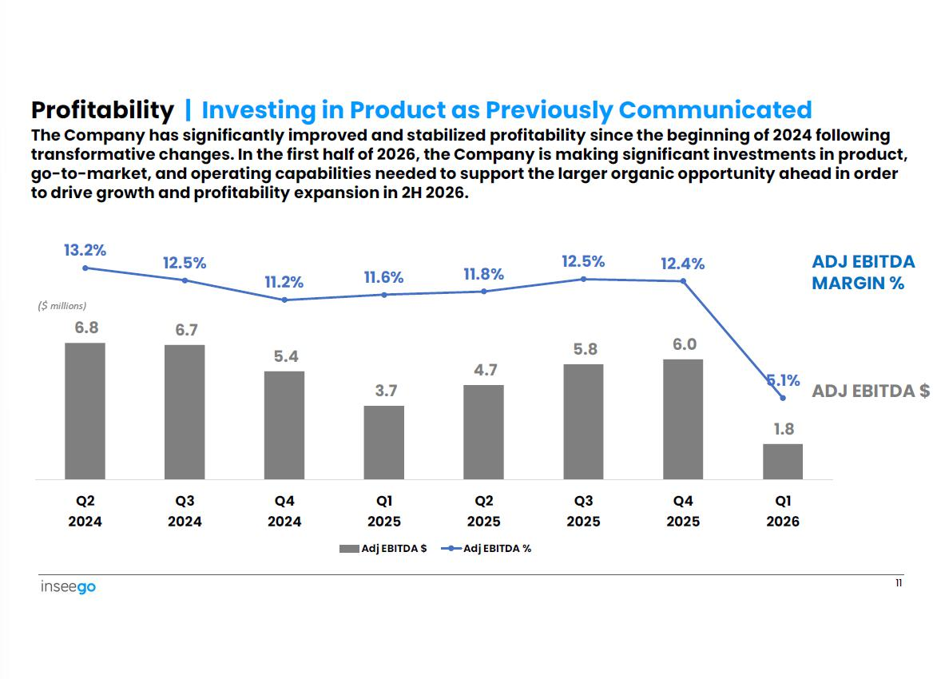

6.7 5.4 3.7 4.7 5.8 6.0 13.2% 12.5% 11.2% 11.6% 11.8% 12.5% 12.4% 5.1% ADJ EBITDA $ 1.8 ($ millions) 6.8 Q2 2024 Q3 2024 Q4 2024 Q1 2025 Adj EBITDA $ Q2 2025 Adj EBITDA % Q3 2025 Q4 2025 Q1 2026 Profitability | Investing in Product as Previously Communicated The Company has significantly improved and stabilized profitability since the beginning of 2024 following transformative changes. In the first half of 2026, the Company is making significant investments in product, go - to - market, and operating capabilities needed to support the larger organic opportunity ahead in order to drive growth and profitability expansion in 2H 2026. 11 ADJ EBITDA MARGIN %

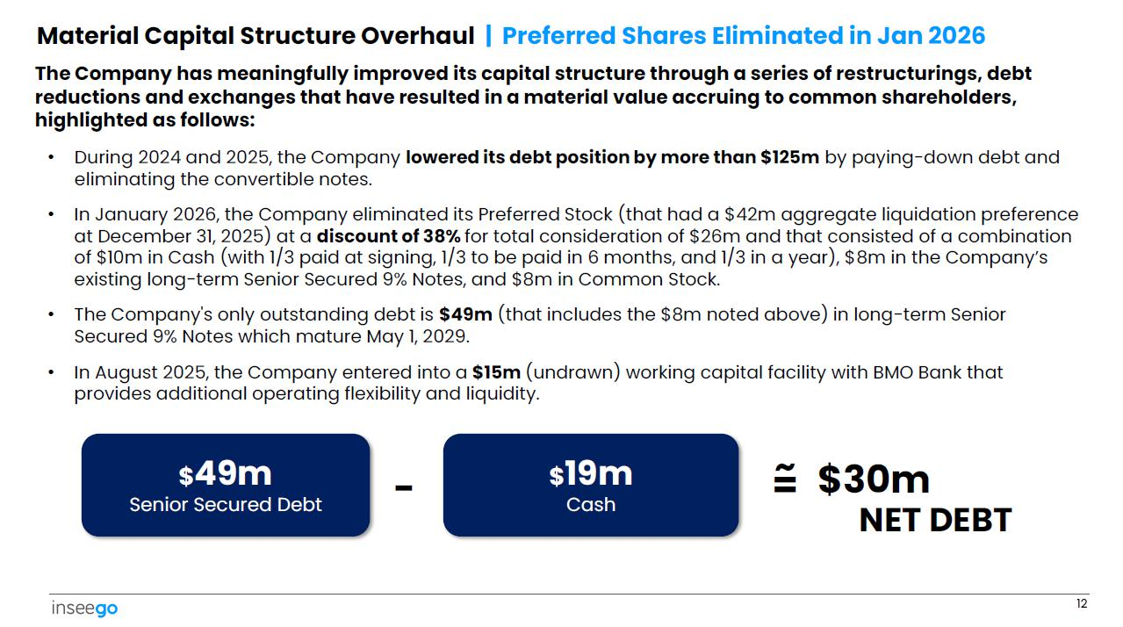

Material Capital Structure Overhaul | Preferred Shares Eliminated in Jan 2026 The Company has meaningfully improved its capital structure through a series of restructurings, debt reductions and exchanges that have resulted in a material value accruing to common shareholders, highlighted as follows: • During 2024 and 2025, the Company lowered its debt position by more than $125m by paying - down debt and eliminating the convertible notes. • In January 2026, the Company eliminated its Preferred Stock (that had a $42m aggregate liquidation preference at December 31, 2025) at a discount of 38% for total consideration of $26m and that consisted of a combination of $10m in Cash (with 1/3 paid at signing, 1/3 to be paid in 6 months, and 1/3 in a year), $8m in the Company’s existing long - term Senior Secured 9% Notes, and $8m in Common Stock. • The Company's only outstanding debt is $49m (that includes the $8m noted above) in long - term Senior Secured 9% Notes which mature May 1, 2029. • In August 2025, the Company entered into a $15m (undrawn) working capital facility with BMO Bank that provides additional operating flexibility and liquidity. $ 49m Senior Secured Debt $ 19m Cash 12 - NET DEBT = ~ $28m

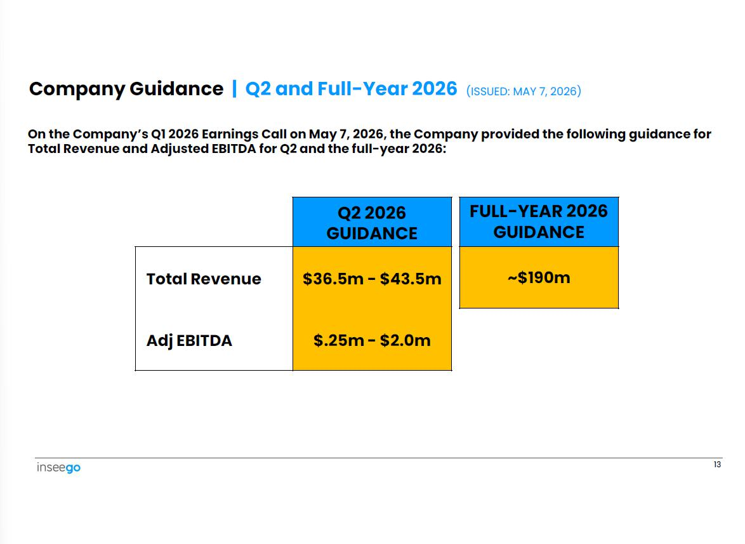

Q2 2026 GUIDANCE $36.5m - $43.5m $.25m - $2.0m Total Revenue Adj EBITDA 13 FULL - YEAR 2026 GUIDANCE ~$190m On the Company’s Q1 2026 Earnings Call on May 7, 2026, the Company provided the following guidance for Total Revenue and Adjusted EBITDA for Q2 and the full - year 2026: Company Guidance | Q2 and Full - Year 2026 (ISSUED: MAY 7, 2026)

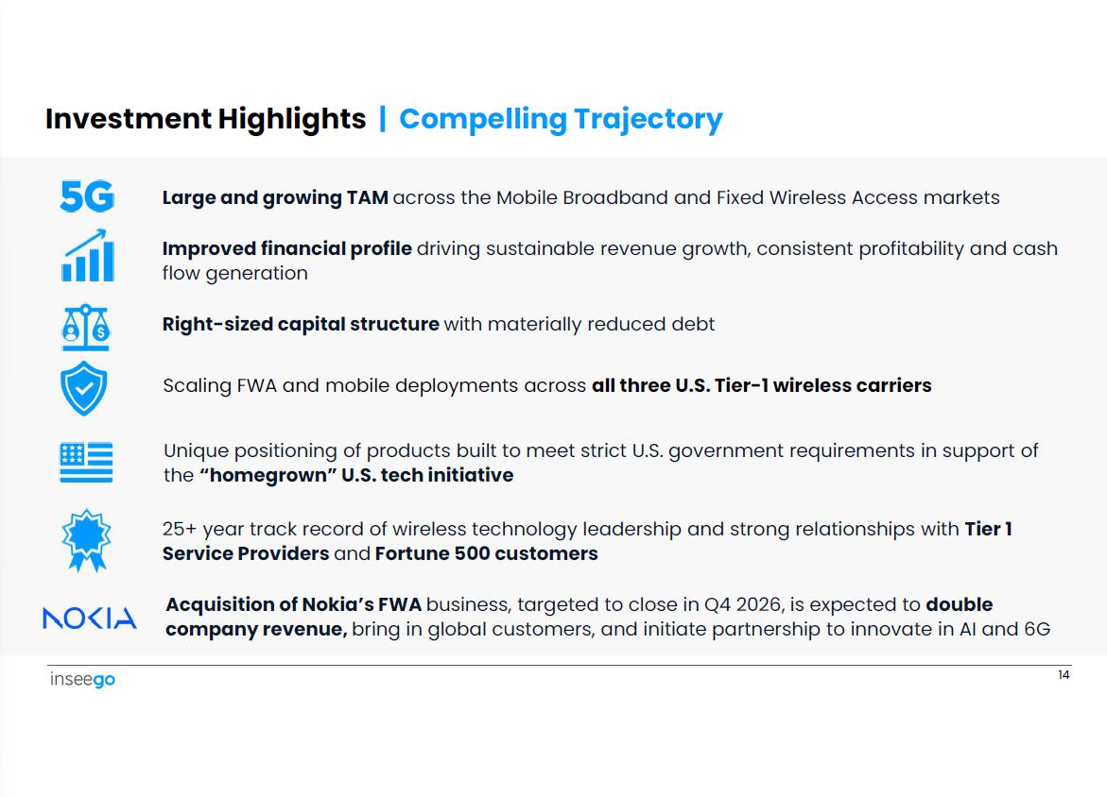

Investment Highlights | Compelling Trajectory Large and growing TAM across the Mobile Broadband and Fixed Wireless Access markets Improved financial profile driving sustainable revenue growth, consistent profitability and cash flow generation Right - sized capital structure with materially reduced debt Scaling FWA and mobile deployments across all three U.S. Tier - 1 wireless carriers Unique positioning of products built to meet strict U.S. government requirements in support of the “homegrown” U.S. tech initiative 25+ year track record of wireless technology leadership and strong relationships with Tier 1 Service Providers and Fortune 500 customers Acquisition of Nokia’s FWA business, targeted to close in Q4 2026, is expected to double company revenue, bring in global customers, and initiate partnership to innovate in AI and 6G 14

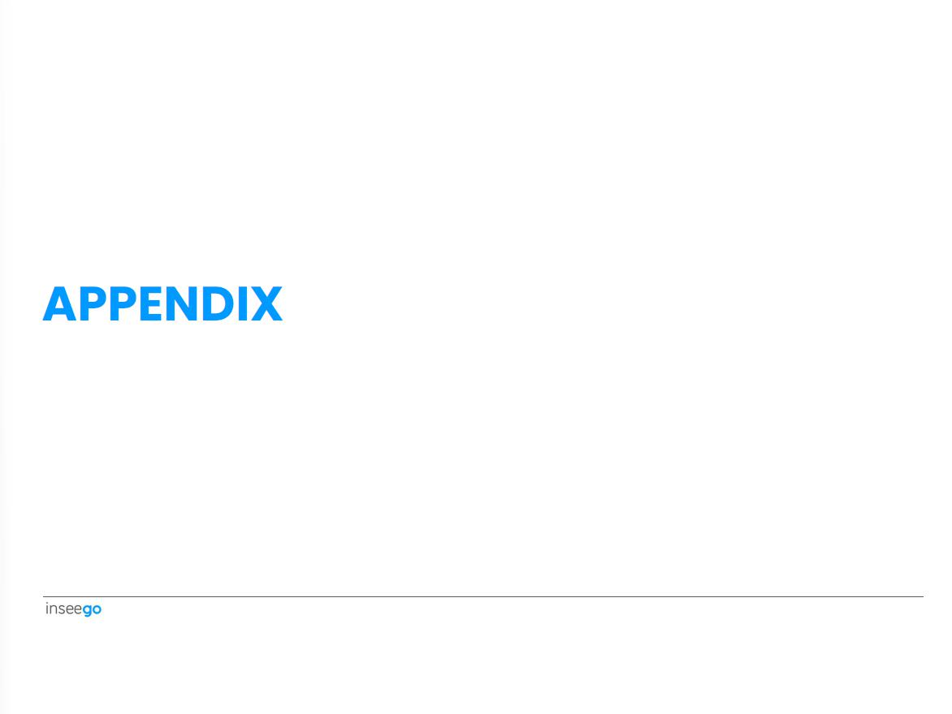

APPENDIX

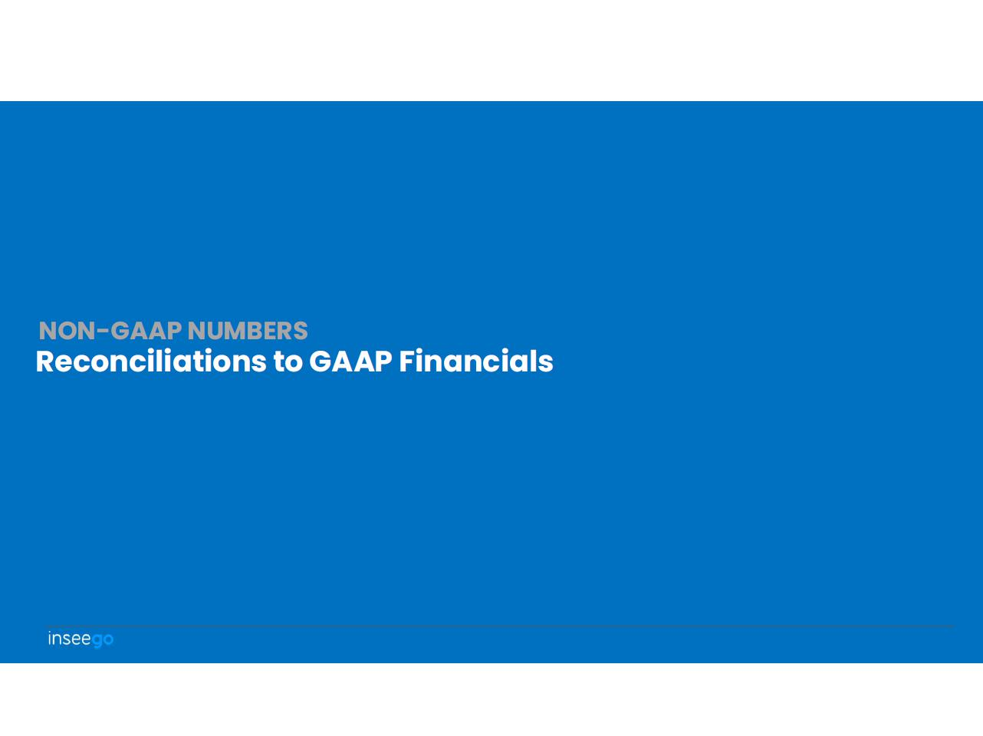

Reconciliations to GAAP Financials NON - GAAP NUMBERS

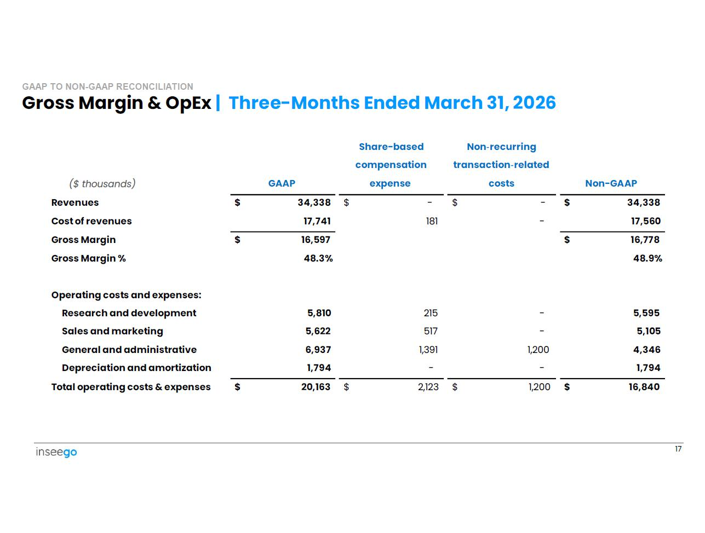

($ thousands) 17 GAAP Share - based compensation expense Non - recurring transaction - related costs Non - GAAP $ 34,338 - $ - $ $ 34,338 Revenues 17,560 - 181 17,741 Cost of revenues $ 16,778 $ 16,597 Gross Margin 48.9% 48.3% Gross Margin % 5,595 - 215 5,810 Operating costs and expenses: Research and development 5,105 - 517 5,622 Sales and marketing 4,346 1,200 1,391 6,937 General and administrative 1,794 - - 1,794 Depreciation and amortization $ 16,840 1,200 $ 2,123 $ $ 20,163 Total operating costs & expenses Gross Margin & OpEx | Three - Months Ended March 31, 2026 GAAP TO NON - GAAP RECONCILIATION

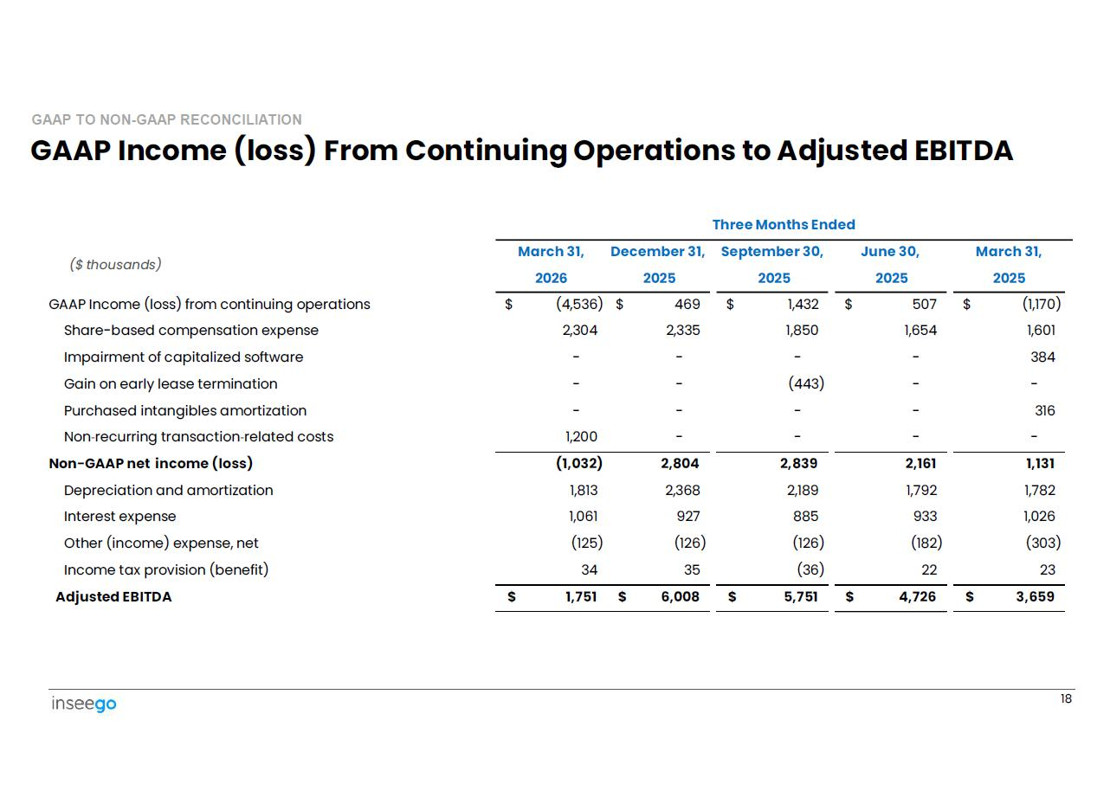

GAAP Income (loss) From Continuing Operations to Adjusted EBITDA 18 GAAP TO NON - GAAP RECONCILIATION March 31, 2025 June 30, 2025 September 30, 2025 December 31, 2025 March 31, 2026 ($ thousands) $ (1,170) $ 507 $ 1,432 $ 469 $ (4,536) GAAP Income (loss) from continuing operations 1,601 1,654 1,850 2,335 2,304 Share - based compensation expense 384 - - - - Impairment of capitalized software - - (443) - - Gain on early lease termination 316 - - - - Purchased intangibles amortization - - - - 1,200 Non - recurring transaction - related costs 1,131 2,161 2,839 2,804 (1,032) Non - GAAP net income (loss) 1,782 1,792 2,189 2,368 1,813 Depreciation and amortization 1,026 933 885 927 1,061 Interest expense (303) (182) (126) (126) (125) Other (income) expense, net 23 22 (36) 35 34 Income tax provision (benefit) $ 3,659 $ 4,726 $ 5,751 $ 6,008 $ 1,751 Adjusted EBITDA Three Months Ended

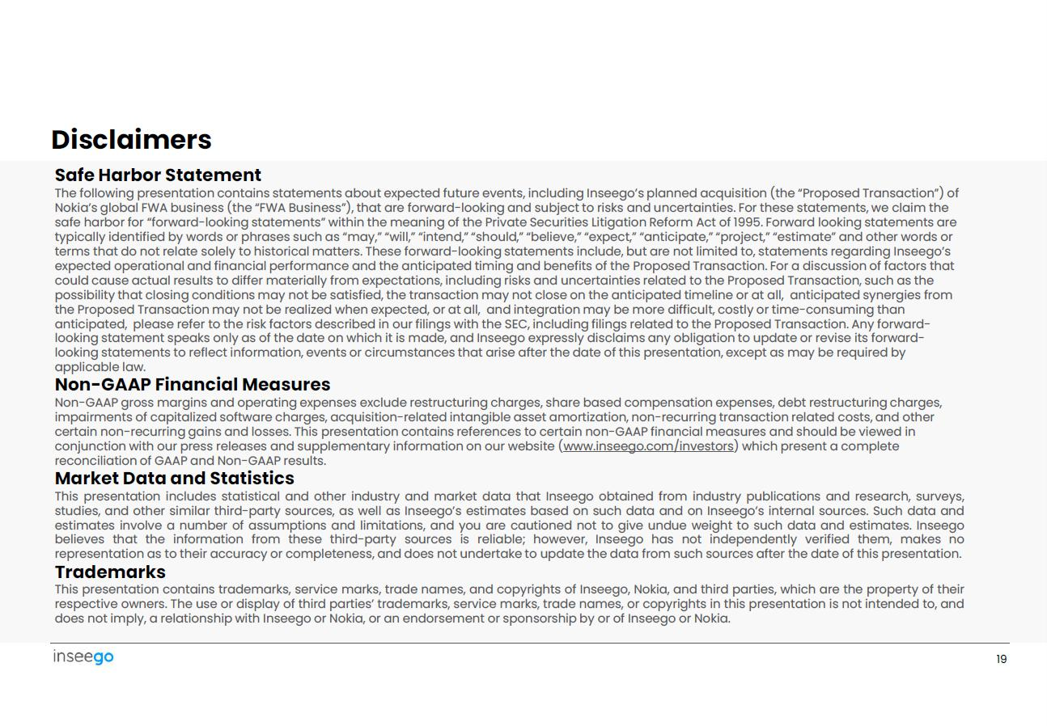

Safe Harbor Statement The following presentation contains statements about expected future events, including Inseego’s planned acquisition (the “Proposed Transaction”) of Nokia’s global FWA business (the “FWA Business”), that are forward - looking and subject to risks and uncertainties. For these statements, we claim the safe harbor for “forward - looking statements” within the meaning of the Private Securities Litigation Reform Act of 1995. Forward looking statements are typically identified by words or phrases such as “may,” “will,” “intend,” “should,” “believe,” “expect,” “anticipate,” “project,” “estimate” and other words or terms that do not relate solely to historical matters. These forward - looking statements include, but are not limited to, statements regarding Inseego’s expected operational and financial performance and the anticipated timing and benefits of the Proposed Transaction. For a discussion of factors that could cause actual results to differ materially from expectations, including risks and uncertainties related to the Proposed Transaction, such as the possibility that closing conditions may not be satisfied, the transaction may not close on the anticipated timeline or at all, anticipated synergies from the Proposed Transaction may not be realized when expected, or at all, and integration may be more difficult, costly or time - consuming than anticipated, please refer to the risk factors described in our filings with the SEC, including filings related to the Proposed Transaction. Any forward - looking statement speaks only as of the date on which it is made, and Inseego expressly disclaims any obligation to update or revise its forward - looking statements to reflect information, events or circumstances that arise after the date of this presentation, except as may be required by applicable law. Non - GAAP Financial Measures Non - GAAP gross margins and operating expenses exclude restructuring charges, share based compensation expenses, debt restructuring charges, impairments of capitalized software charges, acquisition - related intangible asset amortization, non - recurring transaction related costs, and other certain non - recurring gains and losses. This presentation contains references to certain non - GAAP financial measures and should be viewed in conjunction with our press releases and supplementary information on our website ( www.inseego.com/investors ) which present a complete reconciliation of GAAP and Non - GAAP results. Market Data and Statistics This presentation includes statistical and other industry and market data that Inseego obtained from industry publications and research, surveys, studies, and other similar third - party sources, as well as Inseego’s estimates based on such data and on Inseego’s internal sources . Such data and estimates involve a number of assumptions and limitations, and you are cautioned not to give undue weight to such data and estimates . Inseego believes that the information from these third - party sources is reliable ; however, Inseego has not independently verified them, makes no representation as to their accuracy or completeness, and does not undertake to update the data from such sources after the date of this presentation . Trademarks This presentation contains trademarks, service marks, trade names, and copyrights of Inseego, Nokia, and third parties, which are the property of their respective owners . The use or display of third parties’ trademarks, service marks, trade names, or copyrights in this presentation is not intended to, and does not imply, a relationship with Inseego or Nokia, or an endorsement or sponsorship by or of Inseego or Nokia . 19 Disclaimers



www.inseego.com NASDAQ: INSG

